RHEL (Red Hat Enterprise Linux Distribution)

Client OS

Ex- Win 7/8/10/11

Network/Server OS(NOS)

EX- Windows Server,

Ubuntu, CentOS, RHEL

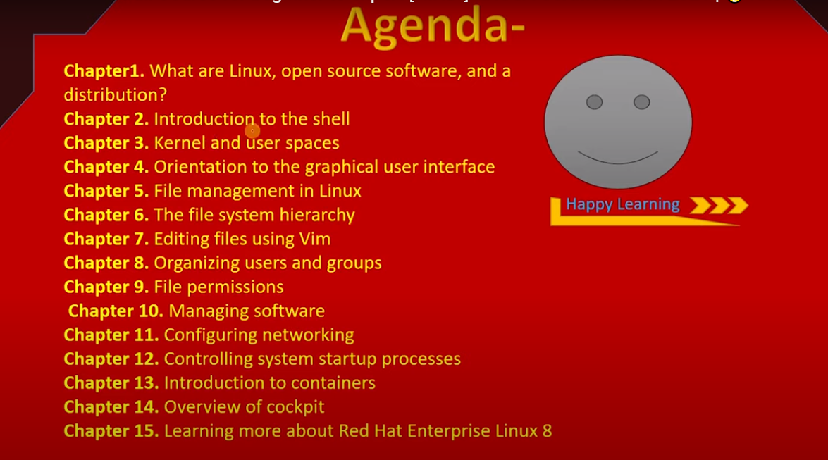

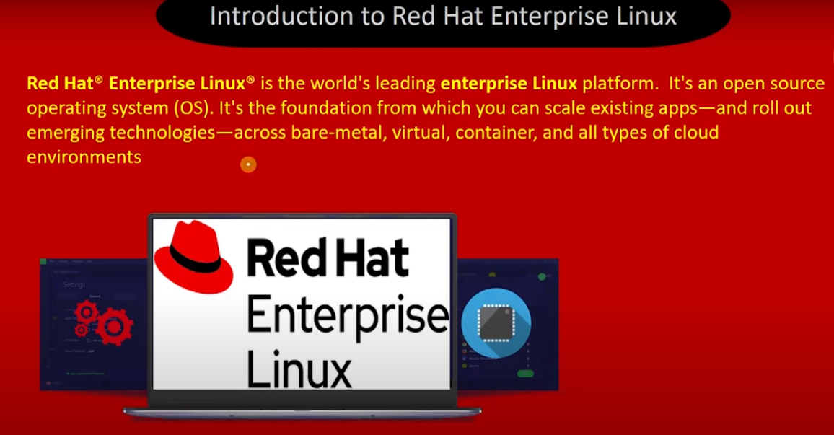

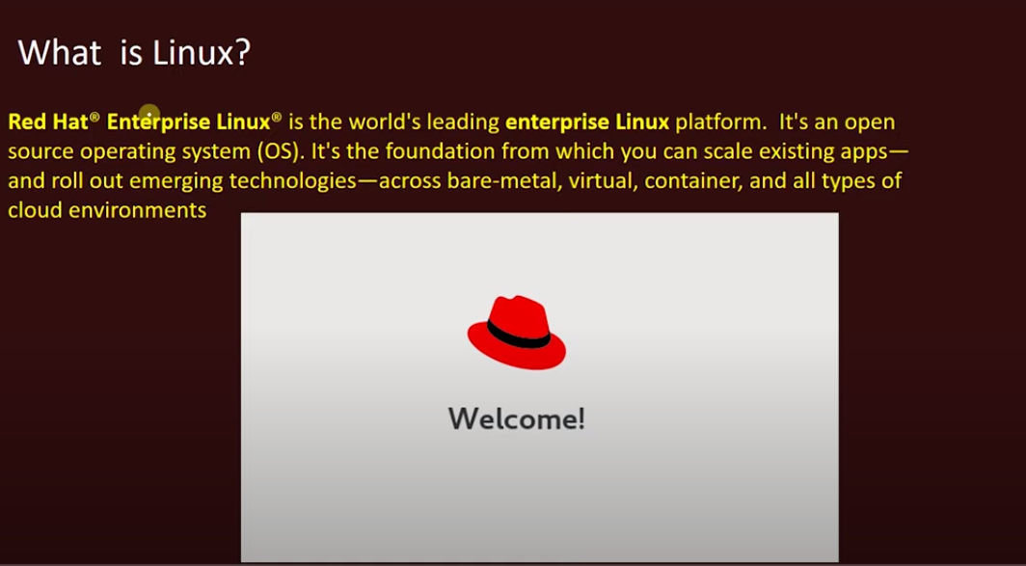

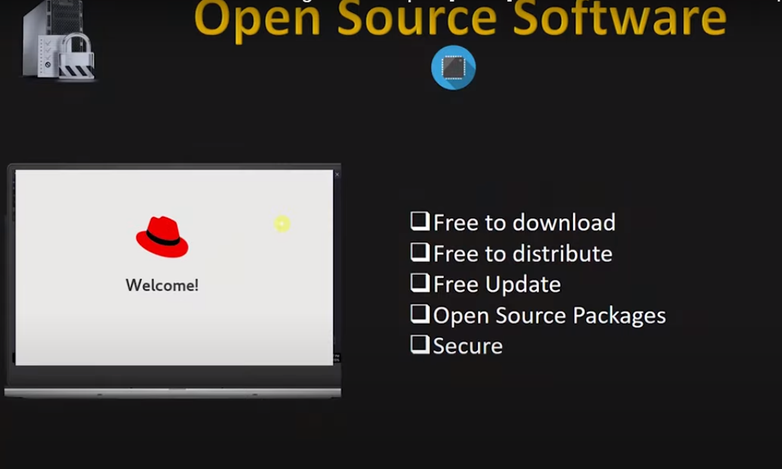

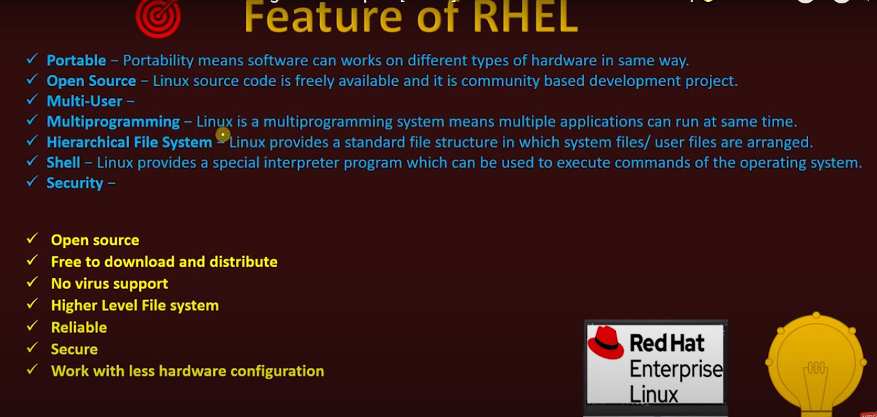

* Linux Boot Process :-
* **Systemd** is the new service manager in Centos/RHEL 7 that manage the boot sequence.
* Every system administrator needs to understand the boot process of an OS in order to troubleshoot effectively.

Works of Boot Process on Linux :-

BIOS 🡪Basic Input and Output Setting(Firmware Interface)

Bios is a firmware Interface. Which is preinstalled in the manufacturing time. It starts up after power on and it works on POST(Power On Self Test) Process.

POST process checks every hardware component(Hard Disk, RAM , FAN etc..) of the system whether all are ok or not.

MBR 🡪Master Boot Record

Information is saved in the fast sector of a hard disk that indicates where the GRUB2 is located so it can be loaded in the computer RAM.

GRUB2 🡪 Grand Unified Boot Loader v2

GRUB2 loads Linux Kernel and that information it takes from

/boot/grub2/grub.cfg configuration file

Kernel 🡪 It is the Core of Operating system.

It makes communication between hardware and it’s related driver.

It loads the required drivers from initrd.img.

It starts the first OS Process (systemd).

Systemd 🡪 System Daemon (PID # 1)

It is the first process of linux os. It’s by default process id is 1.

Reads = etc/systemd/system/default.target to bring the system to run-level Total of 7 run-levels ( 0 thru 6 ).

** Why do we need to learn booting process?

* If we have good knowledge on booting sequence then we can easily handle to perform many task. Like – We can reset the root password trough single user, We can set or remove GRUB password, If initramfs is correfetd then we can fix, If booting files is currefted then we can restore, or else we can restore the system by risqué mode.

** What is meaning of Booting ?

* The process of coping the files of operating system on RAM from hard disk drive is called booting. All the booting files are stored in the /boot directory on the hard disk drive, and those files will be loaded on the RAM in a sequence, and then allows us to use the system after loading all the services and OS component on the RAM.

** Booting Process 🡪

* After Clicking Power Button current will be flow on every devices .
* After that BIOS will be run. BIOS means Basic Input Output System. Which is stored on the BIOS Chef of the mother board.

BIOS is a Firmwhere, which is preinstall inside the system in the manufacturing time. It work on POST( Power On Self Test) Operation.

So After starting the system BIOS checks every devices through the POST Operation/Function whether all are ok or not. Like Hard Disk, RAM, Cooling FAN, BUSes ect..

After checking all the devices BIOS finds MBR (Master Boot Recode) and after finding MBR BIOS gives all the control to the MBR. Now booting process will be starting.

But Now a days we are using UEFI(**Unified Extensible Firmware Interface)** mode instead of BIOS.

* MBR 🡪It is called Master Boot Record. It is saved on the fast sector of the booting device( like hard disk). It is 512 bytes. It supports upto 2TB size, It can create upto 4 Primary partition. In the MBR, Primary Boot Loader information is loaded but It is not a main boot loader. The Primary Boot Loader keeps the sector information about the main Boot Loader and here GRUB2 is the main boot loader and It points to the GRUB2 main boot loader.
* GRUB2 🡪 So MBR points to the GRUB2 main boot loader. GRUB2 full form is Grand Unified Boot Loader Version 2. It loads the Kernel into the RAM form /boot/grub2/grub.cfg configuration file.

Then it provides you to select the kernel option, in which kernel you want to boot up your machine in form of boot menu.

Then it loads the selected/default VMLinuz kernel image from /boot/vmlinuz-4.18.0-2.69.el8.x86_64.

And then it extracts the contents of initramfs image from /boot/initramfs-4.18.0-2.69.el8.x86_64.img and it loads to the RAM.

* Kernel 🡪 Kernel(VMLinuz) finds drivers in initramfs for all the hardware initializations. Then It will initialize all the Hardware by the drivers where it will get all the drivers form initramfs, which is extracts before into the RAM.

Then Kernel executes the /sbin/init system binary file in RHEL 5/6 as the 1st process having process id 1 (PID # 1) .

On RHEL 8, init has been replaced with system & /sbin/init file is a soft link to systemd.

In RHEL 8 –

Ls –l /sbin/init

/lib/systemd/systemd

After That Kernel executes the initrd.target file by the help of initramfs

On RHEL 8, run levels are called as the targets. There are total 7 targets(run levels) present in linux.

Then kernel mounts the root file system into the /sysroot directory as temporary basis.

Then Kernel Root file system will be switched from initramfs root(/sysroot) to system root file system(/) .

Then systemd looks form the default.target.

Systemd reads the file linked by /etc/systemd/system/default.target (it is the softlink of the graphical.target or multi-user.target file) to determine the default system target(runlevel).

Different Target or runlevel are available like ---

Boot in Single User mode, Boot in with network, GUI boot, reboot the machine etc… target are available.

Default Target is GUI boot -- /etc/systemd/system/default.target

